DURATION: 2 Hours

THEORIC CONTENTS

* **Lesson 3.** Data Types.
* **Lesson 4.** Operators and Expressions.

LEARNING OBJECTIVES

* **LO-02.1.** Identify the Variables that are required in algorithm design.
* **LO-02.2.** Identify the Constants that are required in algorithm design.
* **LO-03.1.** Choose correctly the data type of a variable according to the values that it could store in algorithm design.
* **LO-03.2.** Choose correctly the data type of a constant according to the values that it could store in algorithm design.
* **LO-05.1.** Implement variables in C language in function of the type and range of values that is needed in the design of a given algorithm.
* **LO-05.2.** Implement variables in C language in function of the type and range of values that is needed in the design of a given algorithm.
* **LO-06.1.** Implement basic input operations in C language to collect and show data thorught variables.
* **LO-06.2.** Implement basic output operations in C language to collect and show data thorught variables.
* **LO-07.1.** Implement basic input operations in C language to collect and show data throught variables.
* **LO-07.2.** Implement basic output operations in C language to collect and show data throught variables.
* **LO-10.1.** Define and Evaluate expressions, considering values, variables, constants and precedence rules and order of evaluation of each operator.
* **LO-11.1.** Implement in C Language expressions using arithmetic and assignment operators.

GITHUB CLASSROOM ASSIGNMENT

https://classroom.github.com/a/DKgtt3tD

PROPOSED EXERCISES

Exercise 1. Design and implement a C program that calculates the area and perimeter of a circle based on a radius given by the user.

**NOTE:** PI number should be considered as the fixed value 3.14159 and the radius have to be a real number.

Examples of expected output:

Example 1:

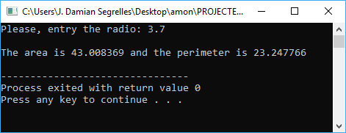

Example 2:

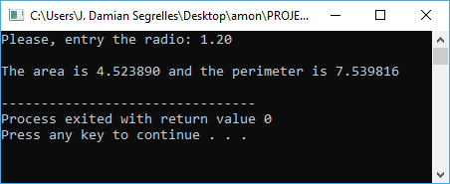

Exercise 2. Design and implement a C program that solves the next problem definition:

A car parts company needs a program that computes and displays the selling price (Euros) of its products. In this sense, the program should apply the following formula:

The cost price and the profit margin are specified by the user. The program should read such values from keyword and then, it should compute the selling price. The result should be displayed on the screen.

**NOTE:** The cost price has to be composed by a number that corresponds to euros and cents, and the profit margin the percentage without decimal part.

Examples of expected output:

Example 1:

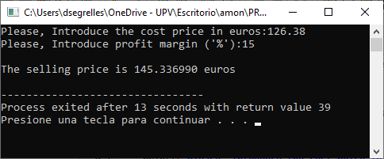

Example 2:

